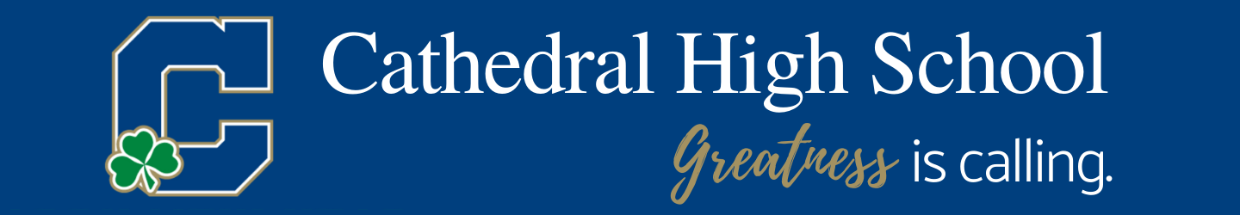

Happy New Year!!! As we enter 2021, know that Cathedral’s Admissions Office is open and available for questions. Please don’t hesitate to reach out to our office, gocathedral.com/admissions or 317-968-7370.

High School Placement Test
Cathedral High School will administer the High School Placement Test on January 23rd and February 20th at 8:30 am. All parents are encouraged to join us for an information session/tour while your student is taking the test. Preregister by visiting www.gocathedral.com/placementtest.

Parents will have the opportunity to enjoy “Coffee with Cathedral” while their student tests. Learn more about Cathedral and tour the school.

Financial Aid
Financial Aid applications can be submitted NOW to gocathedral.com/tuitionassistance. Apply now for the academic year 2021-2022.

Personalized Tours
Please sign up for individual tours through our website, gocathedal.com/admissions, to schedule. These are being offered frequently and are in lieu of other on campus events.

