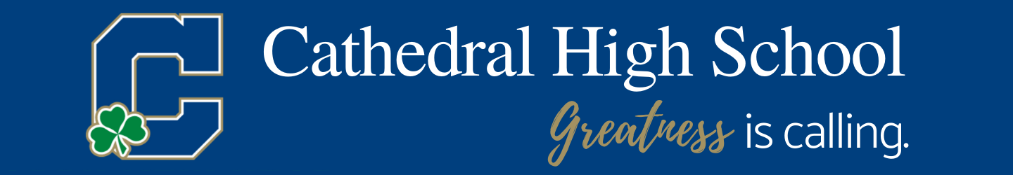

Hello from Cathedral High School. Thank you in advance for publishing the following in your newsletter or bulletin.

High School Placement Test
Cathedral High School will administer the High School Placement Test on the following Saturdays this fall: November 7 and December 5. All tests begin promptly at 8:30 am. All parents are encouraged to join us for an information session/tour while your student is taking the test. Preregister by visiting www.gocathedral.com/placementtest.

Parents will have the opportunity to enjoy “Coffee with Cathedral” while their student tests. Learn more about Cathedral and tour the school.

Application Deadlines
Regular admission applications are due by December 15th. Please go to gocathedral.com/apply to begin the application process.

Financial Aid
Financial Aid applications can be submitted NOW to gocathedral.com/tuitionassistance. If applying for early admission and want your Financial Aid (FA) estimate, FA applications need to be submitted no later than October 31st. Regular admission applications need to be submitted no later than December 15th.

Virtual Opportunities
- Cathedral Virtual Open House! Join us November 12th, 6:00-8:30 pm.

To register please visit gocathedral.com/admissions

Personalized Tours
Please sign up for individual tours through our website, gocathedal.com/admissions, to schedule. These are being offered frequently and are in lieu of other on campus events.

