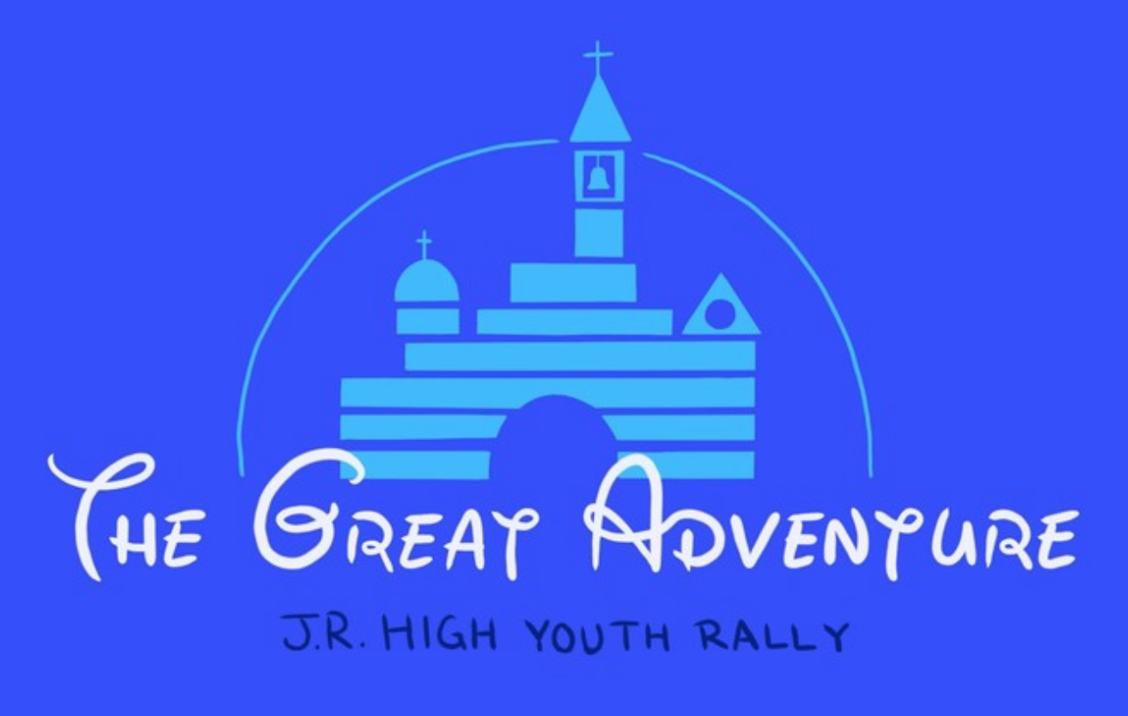

The Great Adventure
2018 Jr. High Youth Rally

Saturday, Feb 3, 2018
1:00 - 7:30 pm

Roncalli High School

The year’s theme is The Great Adventure, allowing our students to enter into their own stories of life and faith.

Scott Boyle, University of Notre Dame, will provide our keynote address, and all sessions will use references from current Disney favorites.
Each student and adult will register for two creative sessions.
− “You’ve got a friend in me.” Toy Story and Friendship
− “Love is putting someone’s needs before your own.” Frozen and Service
− “See the line where the sky meets the sea? It calls me.” Moana and Vocation
− “There’s always a way to turn things around.” Inside Out and Joy of the Gospel
Registration is online at www.nativityindy.org/jr-high-youth-rally. St Luke students can register themselves online using the Other ArchIndy Parishes link.

Registration cost is $30 through January 26. After January 26, the cost increases to $40, and only paper form registrations will be accepted.

Please let Therese Hartley know if you are attending!
thartley@stluke.org, 317-259-4373 (w) or 317-432-2059 (c)

