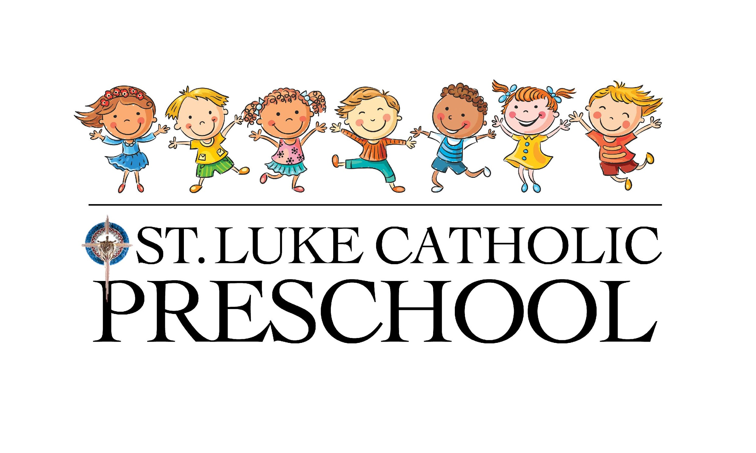
“St. Luke Catholic Preschool has been such a blessing to our family. We know our children are loved by their teachers every day. We love to hear what they learned each day – whether it be a new prayer, new song, story or game. We are very thankful for the early Catholic education and wonderful care they receive.”
Preschool Parent
“You know you’re in the right place when your child runs from your side to give one of his teachers a hug or to play with a friend. That, invariably, is how drop-off at St. Luke Catholic Preschool works.”
Preschool Parent

“Upon going back to work just 3 months after having my first baby, I was so sad/nervous to leave him. All my worries were gone after day one at St. Luke Catholic Preschool! All the teachers there are loving, caring and generous…they treat our baby like their very own! He is always happy when I pick him up and just as happy when I drop him off in the morning. We love St. Luke!”
Preschool Parent

“Great staff! Everyone is caring and kind and willing to help in all areas of the Preschool. Wonderful place for children to interact with other children and learn good social skills. Very Christ centered with several times each day set aside for giving thanks. Also, constantly reinforcing Christian ideals.
Preschool Teacher
“The beautiful smiles and laughter of the children! Seeing the older children interact with these young kiddos is priceless – and so precious!”
Preschool Teacher
“We have greatly enjoyed getting to know St. Luke Catholic Preschool this year! It has been a joy to hear our two year old look forward to going, and then happily jaunting off to play and learn upon arrival. He proudly shows off his art projects when we pick him up. We love that he’s being cared for by people that genuinely care about the future/well-being of children and their faith.”
Preschool Parent
“St. Luke Catholic Preschool allows my daughter to learn skills for kindergarten while also teaching her about her faith. They know my daughter and they love her. I feel good dropping her off in such a loving, supportive place.”
Preschool Parent
“Our baby is adjusting to childcare now that she is going regularly! She loves her teachers who care for her and loves all the toys. One thing I love is getting pictures of her during the day. It always makes my day when a picture comes through!”
Preschool Parent
“St. Luke Catholic Preschool is one of our biggest blessings! Both our 3 year old and our 1 year old light up when they see we’re at Preschool. The Staff love our children like their own and we feel that!”
Preschool Parent
“Our daughter loves her days at Preschool. I know how much she is loved, as she communicates it to me daily. St. Luke Catholic Preschool is an amazing community that works every day to make sure the children are learning, loved and safe!”
Preschool Parent
“How blessed are we to have St. Luke Catholic Preschool serving our parish community! There could not be a more loving environment for the young children who are so fortunate to attend the Preschool/Childcare. Each child is nurtured with love and kindness by an amazing staff. Life-long memories are made in this caring setting for all of our gifts from God.”
Preschool Volunteer

“We are very blessed to have St. Luke Catholic Preschool. My older children did not have this opportunity – to play in the gym, have an older buddy, go to church and lots of other extra-curricular activities. The staff is exceptional and very patient!”
Preschool Parent
“Our family loves the Childcare and Preschool! Each morning at drop-off, my three year old runs out of my arms and into a welcoming room of friends and teachers. She loves coming to the “big school” to play in the gym, visit various grade levels and wave at the school kids. Special dress-up days and PTO activities make the experience even more fun!”
Preschool Parent
“The atmosphere at St. Luke Catholic Preschool is one filled with love, warmth, and joy. You can feel the presence of the Christ-spirit. Teachers engage the children in positive and beneficial ways. The children love being here because they feel genuinely loved.”
Preschool Teacher
“St. Luke Catholic Preschool has been such a wonderful experience. The staff and teachers are so loving, caring and helpful. Each day my daughter comes home filled with fun and joyful stories about her day at school. Every morning she wakes up happy and excited to go to class. She prays for her family, teachers and friends every night. I’m thankful for the amount of patience everyone shows. We love St. Luke Parish and Preschool so much!”
Preschool Parent
“This is our first year at St. Luke Catholic Preschool and we absolutely love it. We love that it is such a family atmosphere. All of the teachers are loving. We also like that the preschoolers get to visit St. Luke School. Our three older children attend St. Luke School and they love every time they get to see their little sister!”
Preschool Parent
“I think we all work together greatly to ensure everything goes smoothly. We have such an awesome team and great families that trust us with their children.”
Preschool Teacher

“The Preschool gives much importance to faith. Dedicated staff are teaching the children. Each child is precious because they are made in the likeness and image of God, so I love them! I also love the Childcare and the Preschool!”
Preschool Teacher
“St. Luke Catholic Preschool is worth the price. Our son would like to come to Preschool every day. “Teachers are very kind and very generous,” he says. This is the best school that we’ve seen in our experience. We are so proud to be a member at this school. Thank you.”
Preschool Parent
“St. Luke Catholic Preschool is filled with love. From the Director, to the Staff, to the beautiful Sisters who work there, everyone loves the children and puts the safety of the children first. If you peek in the Preschool, you might see book reading, song singing, age-appropriate play, outdoor play, craft making, baby cuddling and instilling a love of Jesus through prayer and song. This place is wonderful!”
Preschool Teacher

