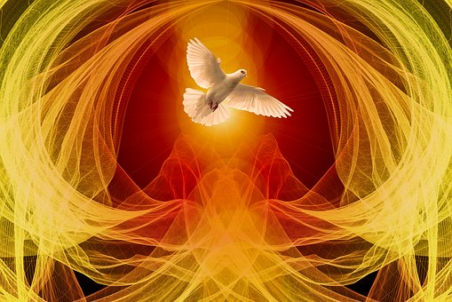

Confirmation will be celebrated on Saturday, August 21, 2021
at 5:00 p.m. at St. Luke Parish

St. Luke Catholic Church
7575 Holliday Drive East
Indianapolis IN 46260
Sister Diane Carollo, S.G.L., Director of Religious Education
Tel. 317-259-4373, ext. 256
dcarollo@stluke.org

Confirmation Program Handbook 2020-2021

“When the day of Pentecost came, they were all together in one place. And suddenly from heaven there came a sound like the rush of a violent wind, and it filled the entire house where they were sitting. Divided tongues, as of fire, appeared among then. All of them were filled with the Holy Spirit and began to speak in other languages, as the Spirit gave them ability.” Acts 2:1-4

Topic Page(s) in Handbook

Welcome to the Confirmation Program 2
Curriculum 2-4
Required Christian Service Projects 5-7
MobileServe instructional videos 4
About Form A……. (Sponsor) 7-8
About Form B…… (Confirmation Name) 8-9
About Form C …… (Essay on Service) 9-10
Instruction on letter to Archbishop 9-10
What to do at adoration 11-13
Prayers and teachings to know 14-16
Form A 17
Form B 18
Form C 19
Assignment for parents and candidates 20
What is a dispensation from Sunday Mass? 21
Prayer during the pandemic 21

Welcome to the Confirmation Program
Welcome to the St. Luke Confirmation Program. Preparation for the sacrament is offered in the 8th grade. The celebration of the sacrament is scheduled for Saturday, August 21, 2021.

Students enrolled at St. Luke School are prepared for Confirmation through their religion classes during the week. All 8th grade students in public and private non-Catholic school settings, and even those attending Catholic High School, who wish to prepare and celebrate the sacrament of Confirmation should register for the weekly SMRE (Sunday Morning Religious Education) Confirmation Program from 10:45-11:50 a.m.

Parents of students not attending St. Luke School may register their child and pay the tuition online for the Confirmation Program 2020-2021. Click on the following link www.st.luke.org/sacraments .

Parents of students in grade 8 at St. Luke School also need to register their children for Confirmation. Go to the parish website to register. A copy of your child’s baptism certificate will be required. Please make sure the school office has your child’s certificate on file.

Due to the COVID pandemic, the Confirmation retreat that is offered each year is cancelled in 2021. Instead of a retreat, a few sessions that focus on Catholic youth currently recognized by the Church for their lives of holiness will be offered. The canonization steps to becoming a saint will also be introduced.

Confirmation Interview
Toward the conclusion of the academic year, Confirmation candidates will be interviewed as part of the Confirmation preparation process.

Confirmation Fees
SMRE students pay $85. per child for the Confirmation Program. St. Luke School students pay no fee in 2020-21 since the Confirmation retreat is cancelled. The SMRE tuition includes book fees. The St, Luke School students pay a separate book fee.

Curriculum
During the Confirmation preparation year, the textbook for the eighth grade is Our Life in the Church. This is part of the Faith and Life Series published by Ignatius Press.

The textbook is used from August through January. Our Life in the Church covers the following:
- The history of the Church — its founding by Christ
- The Church’s birth in the Holy Spirit
- The marks of the one, true Church
- The Fathers and Doctors of the Church
- The Saints
- The role of the religious and laity up to the present
- The structure of the Church Jesus planned
- The role of the Magisterium
- The roles of the clergy, religious and laity

The Confirmation textbook is Spreading and Defending the Faith.
Below is a statement that describes the content of Confirmation book that is published by the Image of God Series.

Through Scripture, the documents of Vatican II, the teachings of Pope John Paul II, and the lives of the saints, candidates for Confirmation are prepared to spread and defend the faith by their words and actions. Activities in the student text include writing articles, conducting interviews, researching lives of saints, and expressing the truth of the faith in an informed way. The teacher's guide helps the catechist direct the students to see the Holy Spirit at work and to respond to His love in all areas of their lives: spiritual, intellectual, moral, service to the Church and community, and more. Features: Prayers, definitions, gifts of the Holy Spirit, apologetics, fruits of the Holy Spirit, vocations, Eucharist, Penance, virtues.

Should classes be suspended due to COVID-19, parents will be advised about virtual learning opportunities for the Confirmation sessions.

Spreading and Defending the Faith

Chapter 1 The Early Church Focuses on the Pentecost Event.

Chapter 2 Confirmation, the Sacrament Focuses on Confirmation’s relation to Baptism and
Eucharist.

Chapter 3 The Mystical Person—Christ and the Church Focuses on the virtues and talents of the Christian that are to be used to serve others. Vocations or callings in the Church are explored.

Chapter 4 The Holy Spirit and Truth Four Gifts of the Holy Spirit are explored. They are: Wisdom, Understanding, Counsel, and Knowledge. The following Saints are introduced: John Paul II, Mother Elizabeth Seton, John Baptist de la Salle, Angela Merici, and John Bosco.

Chapter 5 Defending the Faith Defenders of the faith in the Old Testament and in the Church are discussed. Jeremiah the Prophet, St. Dominic, St. Thomas More, St. Paul of the Gentiles, and St. Ignatius of Antioch are discussed.

Chapter 6 Spreading the Faith The following Saints are introduced: Mother Frances Cabrini, Vincent de Paul and Mother Teresa of Calcutta. The mission of Legatus, a Catholic group of business executives, is discussed since their role is to bring the Catholic faith to the market place. (A chapter from this group meets at St. Luke. Monsignor Schaedel is the chaplain.)
This same chapter explores the Gifts of the Holy Spirit for our wills: Fortitude, Piety, and Fear of the Lord. Also presented are The Twelve Fruits of the Holy Spirit.

Chapter 7 Responding to the Holy Spirit Explains how the Holy Spirit prompts us to pray, obey the Church’s official teachings, and how the Spirit makes us holy through the Eucharist. The chapter emphasizes the need to avoid sin, which hinders the believer from being a genuine witness of Christ. The chapter highlights that the Holy Spirit moves us to serve the poor.

Chapter 8 The Rite of Confirmation

The rite for celebration of Confirmation usually takes place at Mass. One reason for this is that Christian initiation reaches its culmination in the communion of the Body and Blood of Jesus, our Lord.

The bishop is the ordinary minister of Confirmation. However, he may delegate a priest to administer the sacrament.

Sacrament of Confirmation
Presentation of the Candidates—this takes place after the Gospel. The candidates for Confirmation are called by name. They stand and acknowledge that they are present.

Homily

Renewal of Baptismal Promises—after the homily, the candidates stand and the bishop questions them.

The Laying on of Hands—the bishops and concelebrating priests use this biblical gesture and invoke the gift of the Holy Spirit.

Anointing of Chrism—following the Laying on of hands, the candidate and sponsor appear before the bishop. The sponsor places his or her right hand on the candidate’s shoulder and announces the candidate’s Confirmation name to the bishop. The candidate is then anointed with Chrism—a perfumed oil. The baptized receives the indelible character, the seal of the Lord, together with the gift of the Holy Spirit that conforms them more closely to Christ.

The bishops: (Name), be sealed with the gift of the Holy Spirit.

Newly Confirmed responds: AMEN.

The bishop: Peace be with you.

Newly Confirmed responds: AND WITH YOUR SPIRIT.

The General Intercessions

Liturgy of the Eucharist follows

REQUIRED SERVICE PROJECT AND FORMS A – C

25 Hours of Christian Service

The Church teaches us that it is the responsibility of the baptized to live the Gospel in the world. The Confirmation Program teaches your sons and daughters to actively preach and spread the Gospel through their daily activities at home, school, parish and community.

Of course, the service project is never an end in itself. It’s not something to scratch off the list of Confirmation requirements. Christian service projects should teach your children that loving service pleases God and benefits our neighbor. In a very practical sense, Christian service projects should direct youth to love God and neighbor.

Candidates should complete their service hours no later than the end of May. Adults who supervise the candidates will be required to sign off on your child’s service through MobileServe.

In recent years, some students have asked to begin their service projects during the summer months before they begin the new academic year. This is acceptable as long as MobileServe is utilized. Watch the first video that describes how to use MobileServe by clicking on https://info.mobileserve.com/product-overview .

Continue to learn how to use MobileServe by viewing two more brief videos below.
About MobileServe
https://mobileserve.wistia.com/medias/oay1idz6n4

How to Log Hours
https://mobileserve.wistia.com/medias/yynhejtg8n

The 25 Hours of Christian Service should be completed no later than
May 31 for St. Luke School and SMRE candidates.

Service needs to be completed in the following three areas:

1. Prayer and Public Witness
2. Parish and/or School
3. Community
4. Domestic Church

- Each category for service should be selected. Of the total 25 hours, no category should have less than 3 hours. For example, a student may choose 16 hours of Parish/and or School Service, 3 hours for Prayer and Public Witness, 3 hours for Community, and 3 hours for Domestic Church. Other combinations are possible. A student may even exceed the 25 hours of service. In fact, many candidates do exceed the required number of service hours! Acknowledgement of the top three students who complete the most hours will be made at the Confirmation Mass on Saturday, August 21, at 5:00 p.m. at St. Luke Parish.

Throughout the year, there will be service projects offered in the parish and school that count toward the service requirement. It is important to note that the candidate may accept no money for the services rendered. Service is to be performed freely, lovingly and responsibly.

Candidates may not benefit directly from the service they perform. For example, the hours required to raise money for a school trip to Washington, D.C. will not count toward the service hours. If the candidate works beyond the hours required, he/she may earn Christian Service hours.

Altar servers may not accept money for funerals or weddings. They may serve a funeral or wedding, but if they receive payment, they may not count the time toward Christian service. An altar server may accept the money and give it to Monsignor Schaedel to put in a charity fund of his choosing. Monsignor Schaedel may also allow the altar server to designate a charity.

TYPES OF SERVICE PROJECTS

Depending on restrictions due to COVID 19, some of the events listed below may not be possible this year. Domestic Church Service may always be selected when options are limited for service.

1. Under the category of PRAYER AND PUBLIC WITNESS, your child may participate and in public displays of our Catholic faith that are planned in the parish or archdiocese.

- The Respect Life Sunday Mass is celebrated at SS. Peter and Paul Cathedral in Indianapolis on October 6. The archbishop usually celebrates the Mass. It marks the beginning of the Respect Life Program for the archdiocese.

- Lifechain follows the Respect Life Mass. This is an ecumenical event. The faithful line up along North Meridian Street with signs in favor of life. Lifechain is a peaceful and prayerful public witness in favor of the dignity and sanctity of human life. The publicity for the event can be found by visiting the archdiocesan website.

- January 21-22, 2021: Vigil for Life

- Indiana March for Life

- Volunteer services for the Women’s Care Center on 86th Street in Indianapolis. For more information, visit their website at http://www.womenscarecenter.org/locations/indianapolis/ .

- 40 Days for Life (log on to http://40daysforlife.com/indianapolis/ ). Also check out the website for the Great Lakes Gabriel Project for other volunteer initiatives such as collecting clothing for pregnant women and their babies. Go to http://glgabrielproject.org .

- Participation in youth events and retreats sponsored by St. Luke Parish or the archdiocese. Therese Hartley is our parish youth minister. You may contact her at thartley@stluke.org .

- Altar serving. Contact Msgr. Schaedel at jschaedel@stluke.org .

- Singing in the parish and school choirs. Contact Mr. Tom Nichols at tnichols@stluke.org .

- Weekday Masses – School Masses are not included! They may be included if an altar server is absent and a substitute is needed.

- Praying in our perpetual adoration chapel. The supervisor may be the parent or parishioner who is present while the candidate is in adoration. MobileServe must still be used.

2. Under the category of PARISH and/or SCHOOL, your child may participate in a wide variety of tasks and events.

- Service hours may be gained through all types of approved events on the parish or school calendars. If there is a question about the type of service, please email me at dcarollo@stluke.org . Although both the school’s Passion Play and May Crowning are required of the 8th grade students, the powerful and moving spiritual events will count toward PRAYER AND PUBLIC WITNESS. These two required events are the only exceptions that allow candidates to gain Christian Service hours for each event. The teacher will determine the number of hours to be gained.
- The Crowning of Mary by SMRE 8th grade students. Participation will be expected, but students may gain two hours toward Christian Service.

- For all other service opportunities through St. Luke School or SMRE, please consult teachers or Sister Diane.

- Mrs. Diane Schafer, director of spiritual life and formation, will offer opportunities throughout the year for Christian service. Cleaning, decorating and serving meals are some of the projects that may be chosen. Her email is dschafer@stluke.org .

- Serving at Mary’s Way event is another possible way to earn service credits. Contact Mrs. Teresa Schutzman at tcshutzman@yahoo.com

- For other parish events, contact our volunteer coordinator Mrs. Ashley Dirks at adirks@stluke.org.

- For spiritual events for youth, contact our youth minister, Mrs. Teresa Hartley at thartley@stluke.org .

3. Under the category of COMMUNITY, your child may engage in activities that serve the community beyond St. Luke Parish. With your close supervision, candidates may serve the elderly in the community by racking leaves, shoveling walks, babysitting or tutoring younger children and serving the poor. Below are other suggestions for Community service.

- Helping at local soup kitchens
- Sorting items at the St. Vincent de Paul Warehouse
- Collecting non-perishable food for First Sunday Sharing
- Helping to prepare the Thanksgiving Baskets at St. Luke
- Serving at Beggars for the Poor
- Assisting staff at The Humane Society
- Serving at Wheeler Mission

4. Under the category of DOMESTIC CHURCH, your child may engage in activities that directly benefit parents, siblings and other relatives in the home. The term “Domestic Church” refers to the family, the smallest unit, body or group of gathered believers of Jesus Christ. The term dates back to the first century A.D. The Early Church Fathers understood that the home, where the family resides, is the fertile ground for discipleship, sanctification, and holiness. Parents will be responsible for approving the service rendered by their children on MobileServe.

FORMS A, B and C

ABOUT FORM A Confirmation Sponsor DUE NO LATER THAN MARCH 1, 2021
Candidates are free to choose their own Confirmation sponsor. See below what Canon Law says about choosing a Confirmation Sponsor.

REQUIRMENTS FOR GODPARENTS/SPONSORS ACCORDING TO CANON LAW
- A Sponsor must plan to be present if possible and be a guide and example of the Catholic faith.

Can. 892 Insofar as possible, there is to be a sponsor for the person to be confirmed; the sponsor is to take care that the confirmed person behaves as a true witness of Christ and faithfully fulfills the obligations inherent in this sacrament.

- Every sponsor must meet specific requirements. These requirements insure that the role of sponsor is fulfilled well.

Can. 874 §1 To be admitted to undertake the office of sponsor, a person must:
1° be appointed by the candidate for baptism, or by the parents or whoever stands in their place, or failing these, by the parish priest or the minister; to be appointed the person must be suitable for this role and have the intention of fulfilling it;
2° be not less than sixteen years of age, unless a different age has been stipulated by the diocesan Bishop, or unless the parish priest or the minister considers that there is a just reason for an exception to be made;
3° be a catholic who has been confirmed and has received the blessed Eucharist, and who lives a life of faith which befits the role to be undertaken;
4° not labor under a canonical penalty, whether imposed or declared;
5° not be either the father or the mother of the person to be baptized.
§2 A baptized person who belongs to a non-Catholic ecclesial community may be admitted only in company with a catholic sponsor, and then simply as a witness to the baptism.

*If a sponsor is unable to be present for the sacramental celebration, a proxy must be selected.

More things to consider about Confirmation Sponsors

The Sponsor should be confident enough in his or her own faith commitment to be able to support a young person to live out his or her Catholic faith. In other words, a sponsor for Confirmation needs to be a practicing Catholic. The sponsor should live his or her life in conformity with the teachings of the Church.

The sponsor should know the candidate well and be willing to serve as a Christian guide and role model for the candidate. With the parents, the sponsor should be willing to support the young person being confirmed in his/her commitment to live as a good Catholic.

Candidates may certainly choose their baptismal godparents to be their Confirmation sponsors. This emphasizes the important relationship between the two sacraments.

Please note that a parent may not serve as a Confirmation sponsor.

Once the Sponsor is chosen, the candidate needs to fill out the form explaining his or her choice. Form A may be found on page 18 of this Notebook.

ABOUT FORM B Confirmation Name DUE NO LATER THAN MARCH MARCH 22, 2021
In the Catholic Church, we have a tradition of taking the name of a saint for our own
Confirmation name. If the baptism name is not a recognized saint’s name, the candidate needs to research the life of a saint and select a new name for Confirmation. Family members and sponsors may help the candidate with this project.

If the candidates choose to keep their saint’s name from baptism, they still need to do research and write about that saint and why they value his or life. The Confirmation Name Form is found on page 19 of this Notebook.

A good place to start studying the lives of the saints is on the Catholic Online website, www.catholic.org/saints/. The link includes an alphabetical index of saints, an index of patron saints, and a calendar with saints’ feast days.

As candidates consider a Confirmation name, the following questions may be considered:
- How and why did your parents choose your Christian baptismal name?
- What does your baptismal name mean?
- Are there any biblical references to your baptismal name?
- What activities, places, people, etc. interest you? Is there a patron saint associated with any of these activities, places, people, etc.?
- Which saints have their feast day on your birthday?
- Which saints inspire you? Why?
- When and where did the saint you are interested in live? When was he/she canonized?
- How did this saint die? Was he/she persecuted and/or martyred for his/her beliefs?
- What was this saint’s occupation?
- What did this saint’s mission look like?
- What virtues did this saint practice in his/her life? Did this saint always practice these virtues? Did this saint experience a conversion?
- How would you describe this saint’s personality?
- What miracles did this saint perform?
- Are there any symbols associated with this saint? What are their meanings?
- In what ways is this saint a model for Christians today?
- How would this saint act/react if he/she were living in today’s world?

ABOUT FORM C Essay on one Service Project DUE NO LATER THAN MAY 2, 2021

Each student needs to write an essay on one of his or her service projects. A thoughtful reflection on what you did and what you learned or experienced should be written. This essay needs to be submitted with the letter to Archbishop Thompson on May 2, 2021

Go to page 20 to complete the form. A typed essay is preferred.

TYPED Letter to Archbishop Thompson DUE NO LATER THAN MAY 2, 2021

As part of the candidates’ preparation for the celebration of the Sacrament of Confirmation, the archbishop requests that each candidate submit a letter to him. This letter is meant to be more than just a statement from the young person asking for the sacrament. Since he cannot be a part of each and every formation program, the letters help the archbishop to see how the young people have been preparing for this celebration, as well as for life strengthened by the Holy Spirit after the celebration. In addition, so many of the letters stand as a testament to faith and devotion of the young Church, a sign of hope for us all.

Since it is meant to address each young person’s own journey and preparation, the letter should not be a “form letter.” While some guidance may be given, it needs to stand as a composition of that individual. The candidates should note in the letter to which parish they belong.

The archbishop uses the information from the letters as a part of his homily, enabling him to speak to the experiences and needs of the candidates more personally. The archbishop does not use names from the letters in his homily so as not to embarrass anyone, aside from speaking about the selection of the saint name and why

See below how to structure your letter. Remember, this is your personal letter! Be thoughtful, respectful, and sincere when you write.

DO NOT MAIL YOUR LETTER. SISTER DIANE WILL DELIVER THE LETTERS TO THE CATHOLIC CENTER.

The letter should be typed on a white sheet of paper and signed by the candidate.

Parents should read and initial letters of their children!

DO NOT MAIL THE LETTER….. RETURN IT TO THE RELIGION TEACHER AND/OR SISTER DIANE

YOUR NAME

YOUR ADDRESS
City, State, Zip Code
Date: DD/MM/YYYY

Most Reverend Charles Thompson
1400 N. Meridian Street
Indianapolis, IN 46202-2367

Your Excellency:
or Dear Archbishop Thompson:

Tell him why you are writing. You are writing because you want the archbishop to know that you desire to be confirmed on Saturday, August 21, 2021.

Introduce yourself. Tell the archbishop about yourself and your family. Where do you go to school? What are some of your hobbies and interests? You might even attach a photo of yourself or a family photo.

Make sure you answer all 6 questions that are listed below.

- What does Confirmation mean to you?
- Why do you want to be confirmed?
- What saint's name did you choose and why?
- Whom did you choose for your sponsor and why?
- What are some of the things you did for your service hours?
- What did you learn from at least one of the service projects?

If you wish to share a more personal message with the archbishop, you may do so in the letter. Is there something happening in your life that needs prayer? What do you want him to know about your life of faith?

During the archbishop’s homily, he may quote something from your letter. Be careful what you write!

Come to a conclusion in your letter. For example, tell him that you will pray for him.

Yours Faithfully, (You may use another complimentary close. Examples: Sincerely, Yours truly, Respectfully, etc.)

Sign your name in this space above your typed name
Type your full name below your signature

THINGS TO DO DURING EUCHARISTIC ADORATION

Taken from https://prayers4reparation.wordpress.com/.../things-to-do-during-eucharistic-adoration. Additional suggestions added below.

WHAT IS EUCHARISTIC ADORATION?
Eucharistic adoration is the act of worshipping God as He is present in the consecrated Eucharist. Since the Last Supper, when Jesus broke the bread and distributed the wine, saying, “This is my Body” and “This is my Blood”, Catholics have believed that the bread and wine are no longer merely baked wheat and fermented grape juice, but the actual living presence of the Second Person of the Trinity. Spending time before the Blessed Sacrament, in prayer and devotion, is exactly the same as spending time before the living God. Adoration occurs whenever someone kneels in front of a tabernacle that contains the Blessed Sacrament, genuflects towards a tabernacle, bows before receiving the Blessed Sacrament at Mass, or, in a more focused way, when the Blessed Sacrament is exposed for adoration.

THINGS TO DO DURING EUCHARISTIC ADORATION:
Fr Benedict Groeschel points out in “In the Presence of Our Lord: The History, Theology, and Psychology of Eucharistic Devotion” that there are ‘four kinds of prayer most appropriate in the presence of the Eucharist, namely adoration and praise, thanksgiving, repentance, and trusting intercession’. Here are suggestions what to do during private Eucharistic adoration.

1. PRAY THE PSALMS
Whether you are praising, giving thanks, asking for forgiveness, or seeking an answer, you’ll find an appropriate psalm. St. Luke’s perpetual adoration chapel has Bibles at each kneeler.

2. RECITE THE “JESUS PRAYER”
Say “Lord Jesus, have mercy on me, a sinner”, repeatedly as you quiet your heart and mind.

3. MEDITATE USING SCRIPTURE
Choose a passage from the Bible. Read the words and ask God to let the passage speak to you. Pay special attention to anything that strikes you and ask God what He wishes for you to draw from that passage.

4. READ THE LIFE OF A SAINT AND PRAY WITH HIM OR HER
Most holy men and women have a great devotion to Our Lord in the Eucharist. Therese of Lisieux, Catherine of Siena, Francis of Assisi, Thomas Aquinas, Peter Julian Eymard, Dorothy Day, Mother Teresa of Calcutta, and Baroness Catherine de Hueck are just a few. Read about them and pray their prayers before the Blessed Sacrament.

5. POUR OUT YOUR HEART TO CHRIST AND ADORE HIM
Speak to Jesus, aware that you are in His presence, and tell Him all that comes to your mind. Listen for His response. You will not hear an audible response, but deep in your soul God will speak to you. Listen.

6. ASK FOR FORGIVENESS AND INTERCEDE FOR OTHERS
Think of those who have hurt you and request a special blessing for them. Ask God to forgive you for all the times you have neglected or hurt someone else. Bring before the Blessed Sacrament all those who have asked you to pray for them or need your prayers. Ask the Lord to address their concerns. Pray for peace in the world! Pray for people who have lost sight of God. Pray for their conversions.

7. PRAY THE ROSARY
The late pope Saint John Paul II reminds us, “…is not the enraptured gaze of Mary as she contemplated the face of the newborn Christ and cradled him in her arms that unparalleled model of love which should inspire us every time we receive Eucharistic Communion?” (The Church and the Eucharist, 55) Ask Mary to join you as you gaze on Christ in the Eucharist and as you pray the Rosary.

8. Pray the Divine Mercy Chaplet
In 1931, Our Lord appeared to St. Maria Faustina Kowalska of Poland. He asked her to become the apostle and secretary of God's mercy, a model of how to be merciful to others, and an instrument for re-emphasizing God's plan of mercy for the world. Jesus told St. Faustina to write down His words of Love and Mercy and these messages are compiled in the Diary of St. Faustina entitled “Divine Mercy in My Soul”.

St. John Paul II canonized Sister Faustina on April 30, 2000. This was done on the first Sunday after Easter. It is referred to as Divine Mercy Sunday.

On another occasion, Jesus told St. Faustina this:
"It pleases me to grant everything souls ask of me by saying the chaplet. When hardened sinners say it, I will fill their souls with peace, and the hour of their death will be a happy one. Write this for the benefit of distressed souls; when a soul sees and realizes the gravity of its sins, when the whole abyss of the misery into which it immersed itself is displayed before its eyes, let it not despair, but with trust, let it throw itself into the arms of My mercy, as a child into the arms of its beloved mother. Tell them no soul that has called upon My mercy has been disappointed or brought to shame. I delight particularly in a soul that has placed its trust in My goodness. Write that when they say this Chaplet in the presence of the dying, I will stand between My father and the dying person, not as the Just Judge but as the Merciful Saviour." (Diary, 1541)
It pleases Jesus to grant everything souls ask of him by saying the chaplet.

CHAPLET IS PRAYED USING A TRADITIONAL ROSARY.
SEE PAGE 14 FOR DIAGRAM ON HOW TO PRAY THE CHAPLET.
(Repeat 3 times) O Blood and Water, which gushed forth from the Heart of Jesus as a fountain of Mercy for us, I trust in You!

Our Father, Hail Mary and the Apostle's Creed

For each of the five decades (On each “Our Father” bead of the rosary, pray)

Eternal Father, I offer you the Body and Blood, Soul and Divinity of Your Dearly Beloved Son, Our Lord, Jesus Christ, in atonement for our sins and those of the whole world.

(On each of the 10 “Hail Mary” beads, pray)
For the sake of His sorrowful Passion, have mercy on us and on the whole world.

Concluding prayer (Repeat 3 times)
Holy God, Holy Mighty One, Holy Immortal One, have mercy on us and on the whole world.

Optional Closing Prayer
Eternal God, in whom mercy is endless and the treasury of compassion inexhaustible, look kindly upon us and increase Your mercy in us, that in difficult moments we might not despair nor become despondent, but with great confidence submit ourselves to Your holy will, which is Love and Mercy itself.

8. SIT QUIETLY AND JUST “BE” IN THE PRESENCE OF GOD
Think of a visit to the Blessed Sacrament as coming to see your best friend. Sit quietly and enjoy being in each other’s company. Instead of talking to the Lord, try listening to what He wants to tell you. Be at peace in the presence of the Lord.

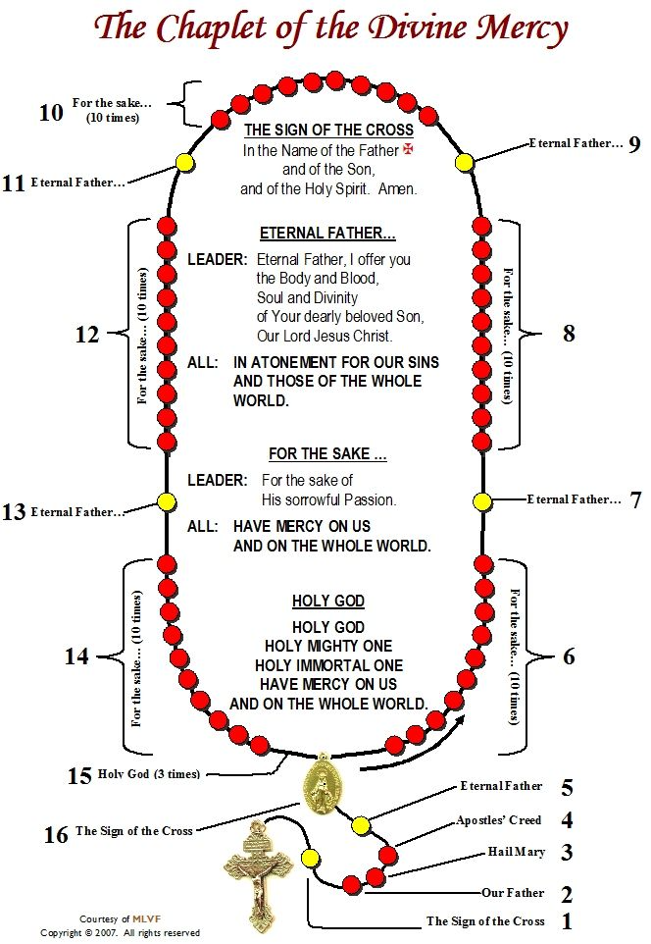

Prayers and Teachings to KNOW

Check the prayers and teachings that you know by heart. Memorize the ones you don’t!

1.The Sign of the Cross
In the name of the Father, and of the Son, and of the Holy
Spirit, Amen.

___2. GRACE BEFORE MEALS Bless us, o Lord, and these thy gifts, which we are about to receive from thy bounty, through Christ, our Lord, Amen.

___3. THE LORD’S PRAYER Our Father, who art in heaven, hallowed be thy name. Thy Kingdom come, thy will be done on earth as it is in heaven.
Give us this day our daily bread, and forgive us our trespasses as we forgive those who trespass against us. And lead us not into temptation, but deliver us from evil. Amen.

___4. HAIL MARY Hail, Mary, Full of grace, the Lord is with thee! Blessed are
you among women and blessed is the fruit of your womb, Jesus. Holy Mary, Mother of God, pray for us sinners, now and at the hour of our death, Amen.

___5. GLORY BE Glory Be to the Father, and to the Son, and to the Holy Spirit,
as it was in the beginning, ever shall be, world without end. Amen.

___ 6. ACT OF CONTRITION

My God, I am sorry for my sins with all my heart. In choosing to do wrong and failing to do good, I have sinned against you whom I should love above all things. I firmly intend, with your help, to do penance, to sin no more, and to avoid whatever leads me to sin. Our Savior Jesus Christ suffered and died for us. In His Name, my God, have mercy. Amen
__7. Rite of Confession Start by making the Sign of the Cross and say: 1. “Bless me Father, for I have sinned. It has been ____ since my last confession, and these are my sins.” 2. Confess your sins. 3. Following your confession, say, “I am sorry for these and all my sins.” 4. Say an act of Contrition. 5. The priest gives you absolution. Say “Amen.” 6. Complete your assigned penance.
__8. TEN COMMANDMENTS 1. I am the Lord, your God. You shall have no other gods besides me. 2. You shall not take the name of the Lord, your God, in vain. 3. Remember to keep holy the Sabbath day. 4. Honor your father and your mother. 5. You shall not kill. 6. You shall not commit adultery. 7. You shall not steal. 8. You shall not bear false witness against your neighbor. 9. You shall not covet your neighbor’s wife. 10. You shall not covet your neighbor’s goods.

____9. Order of the Mass
1. Introductory Rites
2. Liturgy of the Word
3. Liturgy of the Eucharist
4. Concluding Rites

___10. Seven Sacraments: Baptism, Confirmation, Eucharist, Reconciliation, Marriage, Holy Orders, Anointing of the Sick

____11. MORNING OFFERING
O my God, I offer You all my prayers, works, joys and sufferings of this day, for all the intentions of Your Sacred Heart, in union with the Holy Sacrifice of the Mass throughout the world, in reparation for my sins, for the intentions of all our associates, and in particular for the intentions of the Holy Father. Amen.

____12. HAIL, HOLY QUEEN
Hail, holy Queen, Mother of mercy; our life, our sweetness and our hope. To you do we cry, poor banished children of Eve. To you do we send up our sighs, mourning and weeping in this valley of tears. Turn then, most gracious Advocate, your eyes of mercy toward us. And after this our exile show unto us the blessed fruit of your womb, Jesus. O clement, O loving, O sweet Virgin Mary.
V. Pray for us, O holy Mother of God. R. That we may become worthy of the promises of Christ.

____13. Corporal Works of Mercy
1. Feed the Hungry.
2. Give Drink to the Thirsty.
3. Shelter the Homeless
4. Visit the Sick
5. Visit Prisoners
6. Bury the Dead
7. Give Alms to the Poor

____14. Spiritual Works of Mercy
- Counseling the Doubtful
- Instructing the Ignorant
- Admonishing the Sinner
- Comforting the Sorrowful Forgiving Injuries
- Bearing Wrongs Patiently
- Praying for the Living and Dead

____15. Mysteries of the Rosary See page 17 for diagram on how to pray the Rosary.
____The Five Luminous Mysteries
The Baptism in the Jordan
The Wedding at Cana
The Proclamation of the Kingdom
The Transfiguration
The Institution of the Eucharist

____The Five Joyful Mysteries
The Annunciation
The Visitation
The Birth of Our Lord
The Presentation of Our Lord
The Finding of Our Lord in the Temple

____The Five Sorrowful Mysteries
The Agony in the Garden
The Scourging at the Pillar
The Crowning wit h Thorns
The Carrying of the Cross
The Crucifixion and Death of Our Lord

____The Five Glorious Mysteries
The Resurrection
The Ascension
The Coming of the Holy Spirit
The Assumption of our Blessed Mother into Heaven
The Coronation of our Blessed Mother

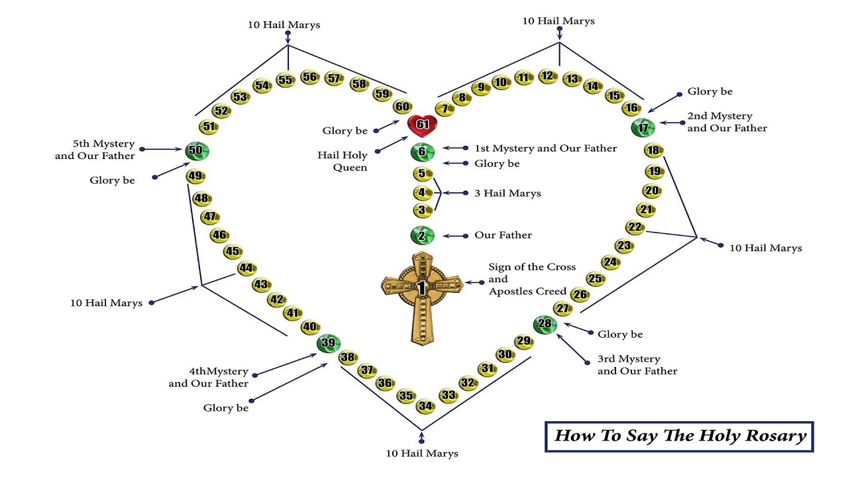

FORM A
St. Luke Church
7575 Holliday Drive East, Indianapolis, IN 46260
Sister Diane Carollo, S.G.L., Director, Office of Religious Education
Telephone: 317-259-4373, ext. 256 e-mail: dcarollo@stluke.org

CONFIRMATION SPONSOR PAPER DUE MONDAY, March 2, 2020

NAME OF CANDIDATE________________________________________________________________________________________

NAME OF SPONSOR __________________________________________________________________________________________

ADDRESS _____________________________________________________________________________________________________

Zip Code

SPONSOR’S TELEPHONE ___________________________________________________________________________________

SPONSOR’S PARISH _________________________________________________________________________________________

ADDRESS _____________________________________________________________________________________________________

In a few paragraphs, explain why you selected this person to be your Confirmation sponsor.

____________________________________________________________________________________________________________________________________________________________________________________________________________________________________________________________________________________________________________________________________________________________

________________________________________________________________________________________________________________________________________________________________________________________________________________________________________

________________________________________________________________________________________________________________________________________________________________________________________________________________________________________

________________________________________________________________________________________________________________________________________________________________________________________________________________________________________

________________________________________________________________________________________________________________________________________________________________________________________________________________________________________

________________________________________________________________________________________________________________________________________________________________________________________________________________________________________

________________________________________________________________________________________________________________________________________________________________________________________________________________________________________

____________________________________________________________________________________________________________________________________________________________________________________________________________________________________________________________________________________________________________________________________________________________

________________________________________________________________________________________________________________________________________________________________________________________________________________________________________

________________________________________________________________________________________________________________________________________________________________________________________________________________________________________

________________________________________________________________________________________________________________________________________________________________________________________________________________________________________
________________________________________________________________________________________________________________________________________________________________________________________________________________________________________

FORM B

St. Luke Catholic Church
7575 Holliday Drive East, Indianapolis, IN 46260
Sister Diane Carollo, S.G.L., Director, Office of Religious Education
Telephone: 317-259-4373, ext. 256 e-mail: dcarollo@stluke.org

CONFIRMATION NAME DUE FRIDAY, March 22 2021

NAME OF CANDIDATE_________________________________________________________

___ I AM KEEPING MY BAPTISMAL NAME – This shows the sacramental connection between your Baptism and Confirmation and is a way to confirm you baptismal promises. Write about your Christian name.

___ I AM TAKING A NEW NAME FOR CONFIRMATION – Choosing the name of a Saint symbolizes a new beginning in your faith and a connection with that particular Saint.

My Confirmation name is ________________________________________________

In a few paragraphs, explain why you made the choice to either keep your baptismal name or select a new name. If the name you were given at baptism is not a Saint’s name, you need to choose a new name.

____________________________________________________________________________________________________________________________________________________________________________________________________________________________________________________________________________________________________________________________________________________________

________________________________________________________________________________________________________________________________________________________________________________________________________________________________________

________________________________________________________________________________________________________________________________________________________________________________________________________________________________________

________________________________________________________________________________________________________________________________________________________________________________________________________________________________________

________________________________________________________________________________________________________________________________________________________________________________________________________________________________________

________________________________________________________________________________________________________________________________________________________________________________________________________________________________________

________________________________________________________________________________________________________________________________________________________________________________________________________________________________________

____________________________________________________________________________________________________________________________________________________________________________________________________________________________________________________________________________________________________________________________________________________________

________________________________________________________________________________________________________________________________________________________________________________________________________________________________________

________________________________________________________________________________________________________________________________________________________________________________________________________________________________________

________________________________________________________________________________________________________________________________________________________________________________________________________________________________________

________________________________________________________________________________________________________________________________________________________________________________________________________________________________________

FORM C

St. Luke Catholic Church
7575 Holliday Drive East, Indianapolis, IN 46260
Sister Diane Carollo, S.G.L., Director, Office of Religious Education
Telephone: 317-259-4373, ext. 256 e-mail: dcarollo@stluke.org

ESSAY ON ONE CHRISTIAN SERVICE PROJECT

DUE WITH THE LETTER TO THE ARCHBISHOP ON MAY 2, 2021

After you have completed your 25 hours of Christian Service, you need to write an essay on one project that was meaningful to you. Write about the project and what you learned from it. Please use complete sentences! A TYPED ESSAY IS PREFERRED.

Include the following:

- Describe your project and where you did your service
- Indicate the number of completed hours for this particular project
- Describe what you experienced and learned from this service project

____________________________________________________________________________________________________________________________________________________________________________________________________________________________________________________________________________________________________________________________________________________________

________________________________________________________________________________________________________________________________________________________________________________________________________________________________________

________________________________________________________________________________________________________________________________________________________________________________________________________________________________________

________________________________________________________________________________________________________________________________________________________________________________________________________________________________________

________________________________________________________________________________________________________________________________________________________________________________________________________________________________________

________________________________________________________________________________________________________________________________________________________________________________________________________________________________________

________________________________________________________________________________________________________________________________________________________________________________________________________________________________________

____________________________________________________________________________________________________________________________________________________________________________________________________________________________________________________________________________________________________________________________________________________________

________________________________________________________________________________________________________________________________________________________________________________________________________________________________________

________________________________________________________________________________________________________________________________________________________________________________________________________________________________________

________________________________________________________________________________________________________________________________________________________________________________________________________________________________________

________________________________________________________________________________________________________________________________________________________________________________________________________________________________________

________________________________________________________________________________________________________________________________________________________________________________________________________________________________________

________________________________________________________________________________________________________________________________________________________________________________________________________________________________________

September 2, 2020

Dear Parents,

At the beginning of the academic year I normally invite parents to a Confirmation meeting at St. Luke Parish. Not to belabor the point, but due to COVID-19 things are simply not normal. As a result, I am asking parents to carefully read and review this Confirmation Handbook. It has important information on all aspects of the Confirmation Program.

In addition to studying the Confirmation Handbook, I am asking parents to watch a YouTube video with their children preparing for Confirmation. The video lasts less than ten minutes. Bishop Barron, a popular speaker and presenter, discusses the Sacrament of Confirmation in a way that I believe will encourage your children to focus on the true meaning of the sacrament. Click on the link provided and listen to what Bishop Barron has to say. Go to https://m.youtube.com/watch?v=f-UuMAU7qT0 .

At some point in the early fall, I will ask the Confirmation candidates at St. Luke School and SMRE several questions about Bishop Barron’s comments. It is my profound hope that you will have discussed the content of the video with them!

If you have any questions or concerns, please feel very free to contact me directly at dcarollo@stluke.org .

Blessings,

Sister Diane Carollo, S.G.L. Director of Religious Education

Dispensation from Sunday Mass

In ordinary circumstances, Catholics are obliged to participate in Mass on Sundays and other holy days of obligation. This obligation has been suspended due to the COVID-19 pandemic. see the joint statement below from the bishops of Indiana on the current dispensation.

“While commending our pastors and pastoral life coordinators who have gone to great lengths to assure safe worship spaces in our churches, due to the increase in the COVID-19 cases in our state, the Indiana bishops have decided to extend the dispensation from the obligation of Sunday Mass attendance beyond Aug. 15 until Nov. 1, 2020, unless further developments determine otherwise.”

A Prayer to Combat the Coronavirus Pandemic

Most Merciful and Triune God,

We come to You in our weakness.

We come to You in our fear.

We come to You with trust.

For You alone are our hope.

We place before You the disease present in our world.

We turn to you in our time of need.

Bring wisdom to doctors.

Give understanding to scientists.

Endow caregivers with compassion and generosity.

Bring healing to those who are ill.

Protect those who are most at risk.

Give comfort to those who have lost a loved one.

Welcome those who have died into Your Eternal Home.

Stabilize our communities.

Unite us in our compassion.

Remove all fear from our hearts.

Fill us with confidence in Your care.

(mention your particular concern and prayers now)

Jesus, I trust in You.

Jesus, I trust in You.

Jesus, I trust in You.

