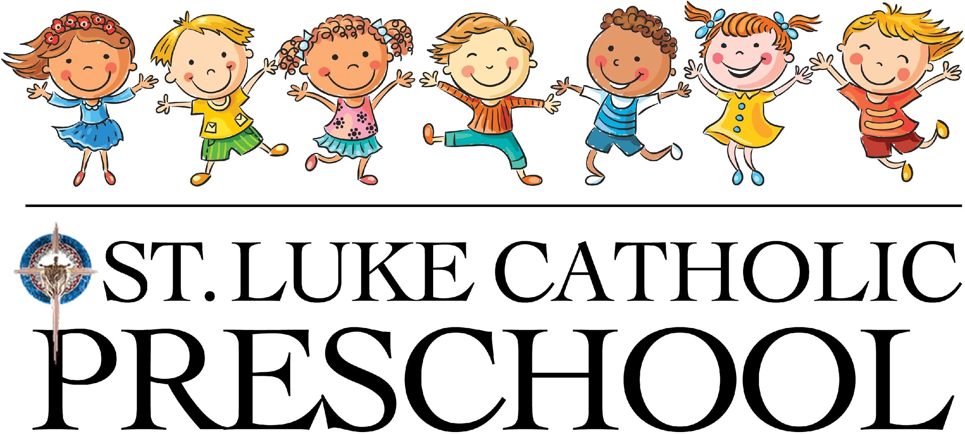

Family Handbook
2020-2021 School Year
Location: 7711 Holliday Drive East, Indianapolis, IN 46260
Mailing Address: 7575 Holliday Drive East, Indianapolis, IN 46260

Director, Mrs. Laurie Breen phone: (317) 974-­9937
email: lbreen@stluke.school website: www.stluke.org/preschool

Mission

The St. Luke Catholic Preschool, with the love of Jesus Christ as our model and guide, is dedicated to serving the staff and families of the St. Luke Catholic Church, School, and community. This ministry seeks to provide a joyful and secure environment for young children to commence a love of learning through a play-­based curriculum. We believe play is the work of children and is essential to their healthy development that will guide each child towards a successful start at St. Luke Catholic School. With teachers as a Catholic guide, every child at the St. Luke Catholic Preschool will develop a lasting relationship with Jesus as they pray, play, explore, question, and learn together.

Admission and Enrollment

Who We Serve St. Luke Catholic Preschool* was established in February 2016 to serve the young children of the St. Luke Catholic community. This ministry offers Childcare for ages 3 months to 4 year-­‐olds, 3’s Preschool and 4’s Pre-Kindergarten.

Registration priority is determined by administration. Tuition and Fees
- A non‐refundable registration fee of $150 per child is collected annually, upon enrollment.
- Tuition rates are subject to change from year to year.
- St. Luke Catholic Preschool uses the FACTS tuition collection system for all tuition payments. Parents must set up an account on the FACTS system before their child begins school. St. Luke Catholic Preschool tuition payments must start in August of each year and will end in May. There is a fee for payment options other than full payment.

*The wording “St. Luke Catholic Preschool” includes Childcare, 3’s Preschool and 4’s Pre-­‐K. When necessary, the handbook will specify a selected program.

  - Financial Policies:

    - St. Luke Catholic Preschool is dependent on the prompt payment of tuition and fees to meet its responsibilities. Parents may pay tuition in one of three ways, 1) over 10 months (August through May) by direct debit, 2) by semester payable in two equal payments, 3) by year with full tuition due in August.

    - Please contact either the Senior Financial Associate or the Parish Manager to correct errors or make special financial agreements. All such agreements must be in writing. Late fees will apply for tuition or fees received after due dates. Note that direct debit of tuition; your parish tithe or other contributions may be set up through the parish office.

    - Parents are responsible for any outstanding tuition or fees, should they unilaterally decide to withdraw their child from the Preschool, once a place is accepted. Requests for consideration of exceptions to this policy, for such things as moving from the city, etc., must be requested in writing to the Director.

    - In case of maternity leave, if a parent would decide to keep their older children at home during their maternity leave, they are at risk for losing their Preschool position. Payment will be expected for child’s absence unless the child’s position can be filled.

    - Our closing time is 4:00pm. A late fee of $5.00 will be charged when you are 1 ‐ 5 minutes late. After 5 minutes, you will be charged $2.00 per minute you are late. You will be notified by email from the Director of your charges.

Operating Policies

Childcare Programs
Full Day Option
choice of 1 to 5 days per week
7:00am-4:00pm

Half Day Option
choice of 1 to 5 days per week
4 - 4.5 hours max
must be picked up by 12:30p

Preschool Programs
PROGRAMS | HOURS OF OPERATION
4’s Pre-­K  ‐must be 4 years old by Sept.1  ‐must be potty trained | Monday, Wednesday & Friday  8:30am­ - 12 Noon  September 9 - May 28
3’s Preschool  -­must be 3 years old by Sept.1  -must be potty trained | Tuesday & Thursday  8:30am - 11:00am  September 8 ‐ May 27
*Before and after school childcare is available for 3’s Preschool and 4’s Pre­‐K
*Enrollment in Childcare includes the Preschool Program if child is of preschool age

Child : Teacher Ratios

CHILD’S AGE | CHILD:TEACHER RATIO
3 months ‐ 12 months | 8 children : 2 teachers
12 months ‐ 24 months | 10 children : 2 teachers
2 year olds | 12 children : 2 teachers
3’s Preschool | 16 children : 2 teachers
4’s Pre‐K | 18 children : 2 teachers

Calendar
  - St. Luke Catholic Preschool will run according to the St. Luke Catholic School teacher calendar. (See enclosed St. Luke School calendar)
  - Choice of 3 beginning dates:
- August 12 (Teacher Retreat)
- August 19 (First day for St. Luke Catholic School)
- September 8 (First week for 3’s Preschool/4’s Pre‐K)

Emergency Weather Closings
  - Closings for St. Luke Catholic Preschool due to emergency weather conditions will follow the same policies of St. Luke Catholic School.
    - St. Luke Catholic School will attempt to make the choice for delayed opening rather than total closing whenever possible. A one­‐hour delay would mean Childcare would open at 8:00am; a two‐hour delay would open Childcare at 9:00am. We will NOT adjust the 4:00 pick‐up time. 3’s Preschool and 4’s Pre­‐K will communicate with parents if there is a delay.
    - TV Channels 6, 8, 13 and 59 will announce emergency closings for St. Luke Catholic School. BE SURE TO LOOK FOR ST. LUKE SCHOOL or ST. LUKE CATHOLIC SCHOOL WHEN THERE IS A CHANCE OF CLOSING DUE TO SEVERE WEATHER. St. Luke Catholic School will not automatically be closed if MSD Washington Township closes.
    - There are no reimbursements for days or hours missed due to closure or delays.
  - In the event of an emergency (loss of heat, electricity, or water) parents may be notified to pick up their children promptly. Emergencies do not guarantee a refund of daily tuition.

Health and Safety
Emergency Evacuation If we need to evacuate the building and cannot return to our St. Luke Catholic Preschool home for an extended length of time, the teachers and children will walk to the St. Luke Parish office. In the event the St. Luke Parish Office must evacuate, the teachers and children will walk to Second Presbyterian Church. Each parent will be notified by phone to pick up his or her child.
Fire and Tornadoes The children will be trained and will practice in performing fire drills. St. Luke Catholic Preschool will have fire drills once a month. In the event of a tornado warning, children are brought to an inner hallway or room away from glass. St. Luke Catholic Preschool will have several practice tornado drills.
Immunizations It is required that we have an up‐to­‐date record of your child’s vaccinations on file at all times. You will be expected to turn this in before your child can start school at St. Luke Catholic Preschool and after each updated vaccine. You may provide your doctor’s vaccination form or use the given form provided by St. Luke Catholic Preschool.
HEALTH We do understand how difficult and frustrating it can be when your child is ill, but it is EXTREMELY important that children do not come to school when they are sick.
- If your child experiences any of the following symptoms within the last 48 hours, please keep them at home until they recover: Fever, vomiting, sore throat, earache, cough, flu, serious cold, eye infection, heavy green nasal discharge, consistent runny nose, skin rash, diarrhea, or other possible contagious illnesses.
- If your child becomes ill at St. Luke Catholic Preschool (fever of 100 degrees or higher), you will be contacted to make arrangements to pick them up. The child must be fever - free for 48 hours WITHOUT medication before returning to school.
- If your child goes to a physician to be treated for a contagious illness (diarrhea, vomiting, flu, etc.), we must receive a note from the physician stating that the child has been seen in a doctor’s office, is not contagious, and may return to school.
- Diarrhea: If your child has diarrhea, please keep him/her home. If your child has 2 or more diarrhea episodes while at school, you will be called to pick him/her up. Your child may not return to school until he/she has a normal bowel movement. Diarrhea due to illness is very contagious.
- Vomiting: If your child vomits while at school, you will be called immediately to pick him/her up. Please keep your child at home until 48 hours after the vomiting has stopped.
- Parents will be informed of any significant injuries and communicable diseases that occur at school through email.

* Below you will find a list of guidelines we will be implementing during the 2020-2021 school year. Parents will be updated accordingly through email if/when we have revised.

- If a positive case of Covid-19 occurs for a child or caregiver, the school will close roughly 2-5 days to facilitate thorough cleaning and work with the local health officials to help determine appropriate next steps.
- Parents should take everyday preventative measures to help protect their family from the spread of Covid-19: avoid close contact with people who are sick, encourage respiratory etiquette (e.g. covering coughs and sneezes with a tissue or sleeve), encourage frequent, proper handwashing with soap and water for at least 20 seconds or with hand sanitizer that contains at least 60% alcohol, keep your child home if sick with any illness.

Medications: Children who are under a doctor’s prescribed medication should remain home for 48 hours or until they are well enough to come back to school. In case of a medical emergency, staff will take the appropriate medical action first and parents will be notified immediately. If necessary, staff will also call the child’s pediatrician and local hospital. If your child requires taking medication while at school, please let the Director know. Instructions must be given to the Director.
  - Prescription medications will not be stored overnight at school.
  - Medication must be in the original container and have the following information:
-­Child’s name
-­Name of medication
-Reason for giving the medication
-How often to give the medication
­-The dosage to be given
­‐Any refrigeration need

Allergies Please alert the director if your child has a serious food, bee sting, or other potentially life-threatening allergy.

Head Lice While head lice does not pose a health hazard, it is highly contagious, especially with young children. Children who have a live louse and/or 2 or more eggs/nits within 1 inch of the scalp will be temporarily excluded from school until treated with the appropriate medication.

Injuries All injuries should be reported as soon as possible to the Director. A written record of the injury will be kept. Serious injuries require a complete incident report being filed. Normal accidents are not covered by the school's insurance. All accidents or injuries will be reported to the parents. A child will be given first aid by the staff. If the injury poses an emergency, 911 will be called. Every attempt to contact parents will be made.

Medical Conditions Please alert the Director of any significant medical condition, such as diabetes, seizure disorders, neuromuscular conditions, cancer, etc. impacting your child’s health.

Universal Precautions Always avoid direct contact with various human body fluids, such as blood. St. Luke Catholic Preschool has universal precaution kits with gloves and first aid kits. All the staff has received Universal Precautions Training.

Asbestos St. Luke School does contain some asbestos in non - friable, sealed locations in the older part of the school. It is considered safe and is inspected on a regular basis. All maintenance personnel are trained to work safely around the asbestos. The asbestos abatement plan is on file in the principal's office and may be reviewed upon request.
Federal law requires this notice.

Safe and Sacred St. Luke Catholic Church, School, and Preschool as well as the Archdiocese of Indianapolis, are charged with protection of all God’s children from harm, especially from sexual or other abuse. All staff and volunteers are required to undergo the Archdiocesan background check, as well as participate in, successfully complete, and update the approved training program. “Safe and Sacred” is the approved online training program for the Archdiocese. The web link may be found at www.archindy.org

Child Abuse and Neglect We are required by Indiana law to report any suspected signs of child abuse or neglect.

Drop-off One vehicle at a time will pull up to the Wellness Check Station (location TBD) and turn off the engine. The parent will unbuckle the child from the car seat and approach Wellness Check Station. They will be given a verbal health screen and temperature check by a staff member. If both are healthy, the child will enter the building with a teacher. Staff will sign-in the child and indicate pick-up time from the parent. Staff will monitor student health throughout the day. If a child and/or parent presents a temperature of 100 degrees or more, the family must leave with the parent. Please allow 5-10 extra minutes for drop-off.

Childcare Sign-­In and Sign-­Out A staff member will sign-in and sign-out each child at the Wellness Check Station each day. Please make sure your child is under the supervision of a teacher before you leave.Pick-up Children will be picked up at the Wellness Check Station (same location as drop-off) of the Preschool. It is helpful for us to know your estimated pick-up time so we have your child(ren) ready. Please call the Preschool (317) 974-9937 when you have arrived and stay in your vehicle. We will bring your child(ren) to you!

Please Note: If an unauthorized person attempts to pick up your child, the child will not be allowed to leave. If an unidentified, but authorized person attempts to pick up a child, identification will be required. The school cannot legally deny release of any child to a natural parent unless there is a written court order. The school cannot allow a child to leave with any inebriated person, even a parent. If, on a given day, your child has permission to leave school with someone other than those authorized individuals listed on the enrollment forms, please advise the Director/teacher in writing or call the preschool office. If you wish to change the names of persons who are authorized to pick up your child at any time, you must do so by written notice.

Late Pick-­up Fees See page 3 “Financial Policies”.

Visitor Policy Parents/Visitors may NOT enter the Preschool during the 2020-2021 school year. Only children and staff members will be permitted. Tours for prospective families will not take place until further notice. A video tour of the facility will be shared with families once the interior renovation is complete and rooms are set up.

Supplies A supply list will be sent out to each registered child. Additional supplies may be requested throughout the year.

Snacks At the beginning of every month, we are requesting that each family provides 20 NUT-FREE individually packaged snack packs. With the new health and safety guidelines, we cannot accept any snacks other than snack packs. Mid-morning snacks will be offered to all children. Afternoon snacks will be offered to full-day children. We are a NUT FREE school. Please do not send any snack with peanuts, peanut butter, tree nuts.

Birthdays We celebrate birthdays during snack period. St. Luke Catholic Preschool provides the birthday treat for all the students. Please do not send cupcakes or other treats to share because of food allergies. Your child may choose a book from home for a class read aloud or donate a book to the classroom library. If you wish to send birthday invitations through the school, the entire group must be invited to prevent hurt feelings.

Personal Belongings St. Luke Catholic Preschool is not responsible for the damage, loss, or theft of personal property. This is in accordance with Archdiocese insurance requirements. All personal belongings that might become separated from a child should be labeled with the child’s name. All outer garments, including coats, mittens, hats, etc. should be labeled with your child’s name. Children should not bring personal items such as money, toys, etc. unless requested by the teacher.

Behavior The ultimate goal of St. Luke Catholic Preschool is to develop a Christian child whose habits are consistent with good moral principles and Catholic values. We strive to create a loving environment in which all children, their rights, and belongings are respected. Positive reinforcement builds a child’s self-­‐worth and encourages the formation of the whole child. The limits for children at St. Luke Catholic Preschool are set for their safety.
We encourage children to find alternatives to confrontation in stressful situations. Techniques include: giving choices, problem solving, natural and logical consequences, redirecting, and thinking time. Our goal is to create a positive learning atmosphere.

Physical Contact Hitting, pushing, shoving, or any other physical contact by a child will not be tolerated by St. Luke Catholic Preschool staff. In addition BITING is a typical behavior for toddlers to seek attention or express their feelings. It will always be discouraged and the child will be helped to find other solutions. If biting becomes a problem, the teachers will meet with the parents to find a solution. Our policy is to provide first aid if needed and the incident will be documented, parents will be informed, and if the child bites two times in one day, parents will be called to take the child home. We must keep the children’s safety first. Names of the children will not be disclosed to insure each family’s privacy.
Confidentiality Information about child and family will remain confidential at all times.

Divorce and Legal Separation Parents who are divorced or legally separated must provide legal (court) documents regarding custody, financial responsibility and other information related to the educational well - being of the children involved. Both parents have access to school and academic information unless restricted by a court order. Parents have the responsibility of keeping the school informed in writing of any changes. Contact the Director if you have any questions.

Worship and Prayer Our preschool is Catholic, and this means that we stress our heritage and traditions. Students and staff at St. Luke Catholic Preschool are expected to make prayer a key part of daily life. Prayers throughout the day and before meals are the norm. Respectful behavior during prayer time is expected. Parents and children are encouraged to take time for regular prayer. Parents are expected to make attending Sunday worship a family priority.

St. Luke Catholic Preschool is an Unlicensed Registered Ministry in the State of Indiana

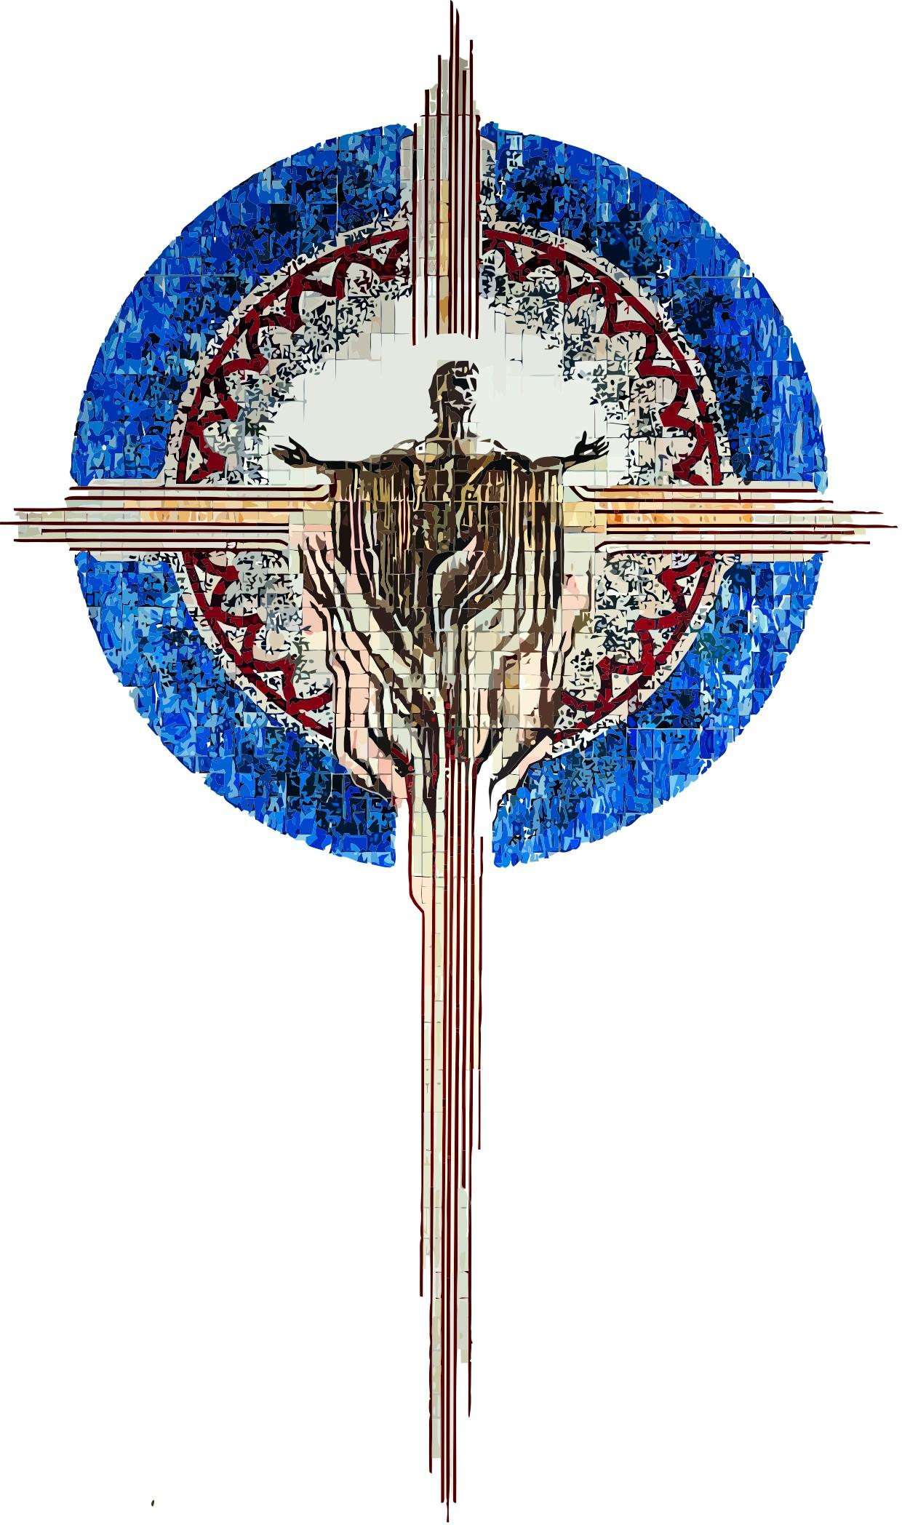
Receipt for St. Luke Catholic Preschool Handbook

I have received my copy of the St. Luke Catholic Preschool Handbook. I agree to read it and keep it for future reference. I agree to abide by all the procedures and policies as stated in the handbook.

________________________________________________________
Full Name (print)

________________________________________________________
Signature

________________________________________________________
Child’s Name

________________________________________________________
Date

