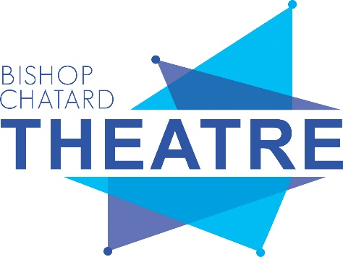
For Immediate Release
Contact: Hayden Redelman, haydenredelman@att.net

The Bard is Coming to Bishop Chatard, October 24 & 26
“THE COMPLETE WORKS OF WILLIAM SHAKESPEARE – ABRIDGED”
Think you know the story of Romeo and Juliet? “The Complete Works of William Shakespeare – Abridged” offers an off-beat take on the Bard’s classic comedies and tragedies – all condensed into one hour and thirty minutes! You’ll laugh – and learn a lot about the greatest playwright of all time.
Bishop Chatard Theatre is proud to present “The Complete Works of William Shakespeare – Abridged” on Thursday, October 24 and Saturday, October 26. Tickets for the show are now available for purchase online: www.bishopchatard.org/arts/tickets. North Deanery students with Future Trojan Pass receive free tickets.

