Preschool and School Videos

We are so fortunate to have videos of our preschool and school. We are also very thankful to our teachers and parents who have helped put these together.

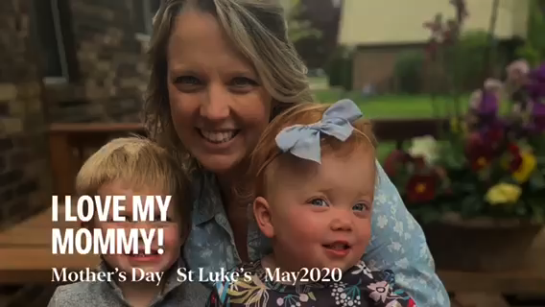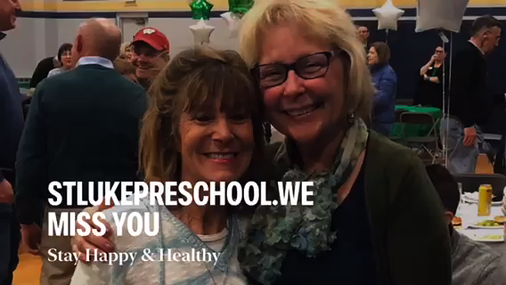Preschool Videos
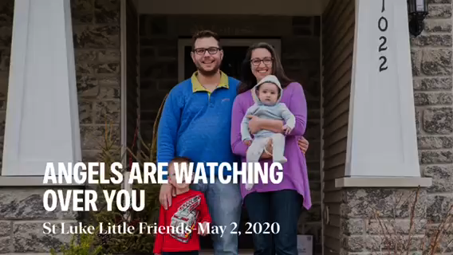

School Videos

Tribute to May Crowning
https://www.youtube.com/watch?v=EPKemmR6EcI

Tribute to Alumni Mass 2020
https://www.youtube.com/watch?time_continue=41&v=A3MSEtNAcpg&feature=emb_logo

6th grade Last Supper video link...
https://www.youtube.com/watch? v=68h6-YIGKc8

8th grade Stations of the Cross video link...
https://youtu.be/ YFVSZ9kKsBg

