

Dear Parents:

This year we will be participating in the **WordMasters Challenge™**. For over 25 years, **WordMasters** has been helping students:

* Expand their vocabulary
* Develop verbal reasoning skills through the use of analogies, and
* Most importantly, have **fun**!

*“Thanks for the terrific year! My students discovered the power of words and*

*enjoyed adding so many to their vocabulary! We had a great time!”*

*–Ames Middle School*

The **WordMasters Challenge™** consists of three 20-minute analogy-solving meets held at school throughout the year (December, February and April). Prior to each meet, the students are given a list of 25 challenging vocabulary words that will appear in the Challenge Test analogies. Excellence in the competition will require both a mastery of the word meanings and thoughtful reasoning about the relationships between the words.

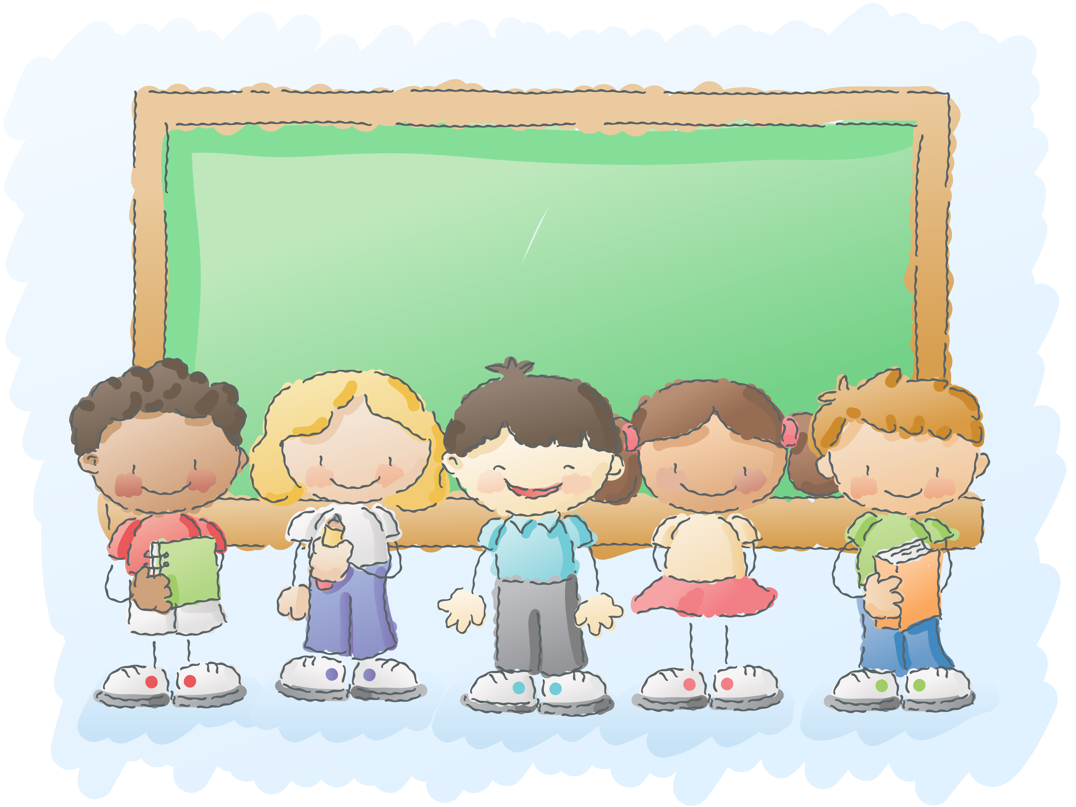**Join the Learning!**

Help your child practice their words at home, and learn some new words along the way.

Ways to Help

You also are invited to sign-up for **WordMasters’** **monthly newsletters** via e-mail by filling out the form on their website’s homepage.

Test your own vocabulary knowledge (or quiz your friends) with the **WordMasters** **“Analogies of the Day”**. Answers to the daily analogy are posted the next day. To join in:



Find **WordMasters™** on Twitter and Facebook!