

_____________________ _____________________

_____________________ _____________________

_____________________ _____________________

_____________________ _____________________

_____________________ _____________________

_____________________ _____________________

_____________________ _____________________

_____________________ _____________________

_____________________ _____________________

_____________________ _____________________

_____________________ _____________________

_____________________ _____________________

_____________________ _____________________

_____________________ _____________________

_____________________ _____________________

_____________________ _____________________

WordMasters Challenge™ is a great way to grow your vocabulary, learn how words are related, challenge yourself and have **fun**!

“I’ve had a blast doing WordMasters for the past three years.” Jamie, 5th grade student

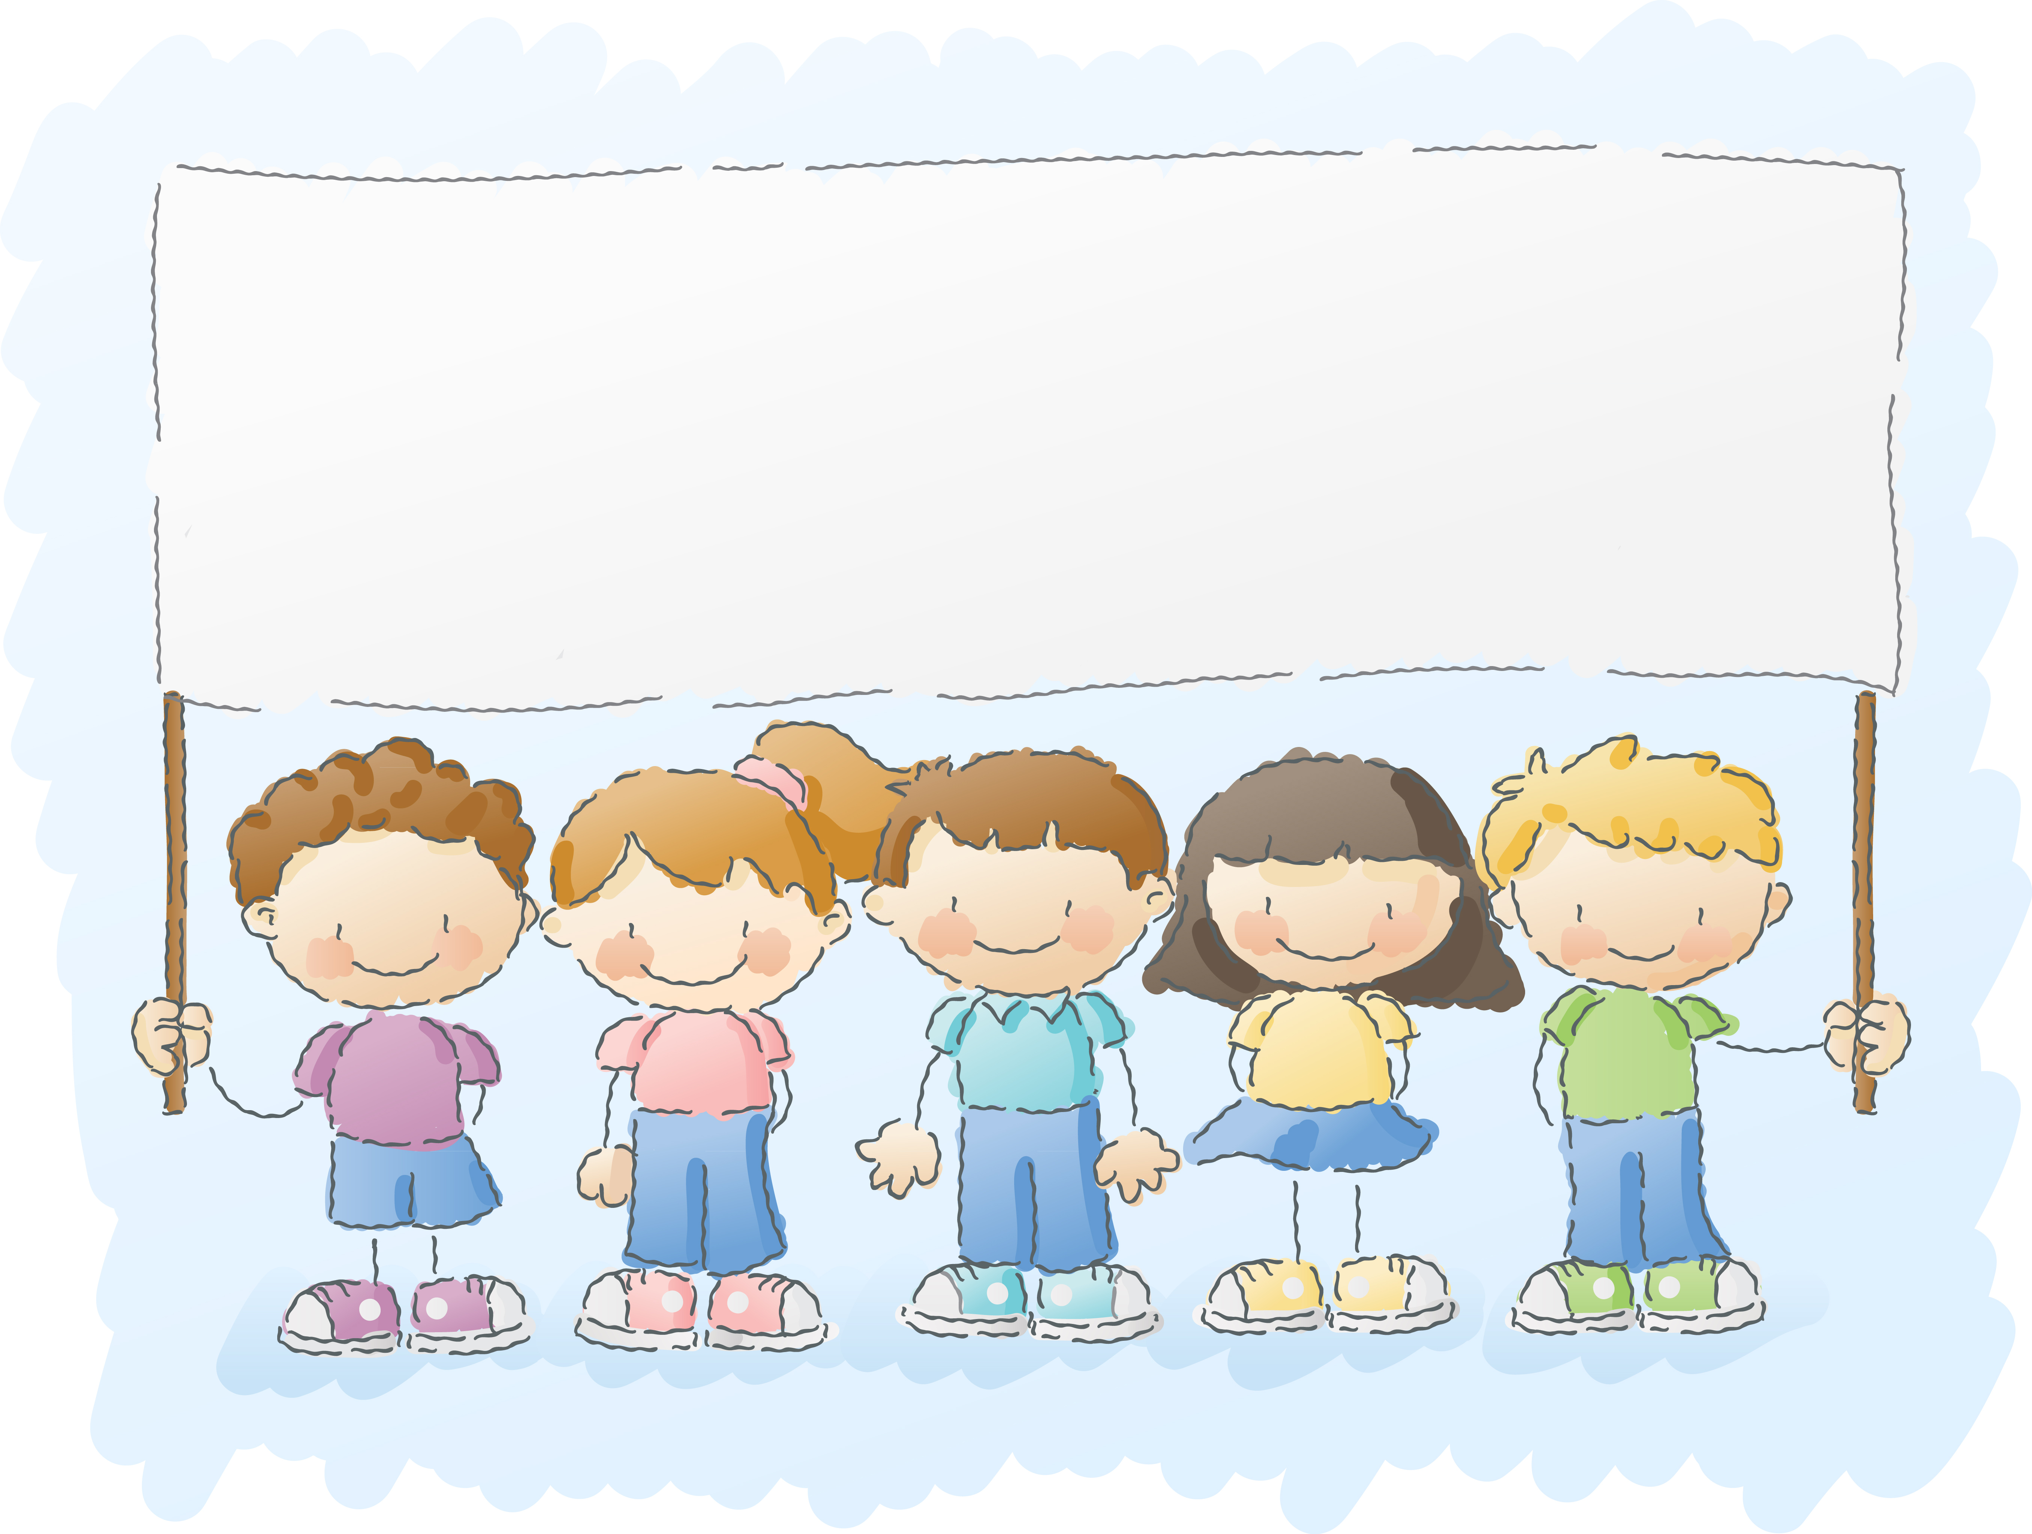

Join Our WordMasters Team!